Stamford University Bangladesh

Spring 2022
Lab Assignment

CSI 234: Advanced Programming Sessional
Course Teacher: Santa Maria Shithil

Name: Tasin Shahriar Chowdhury
ID: CSE 069 08060
Batch: 68(A)

Task 1
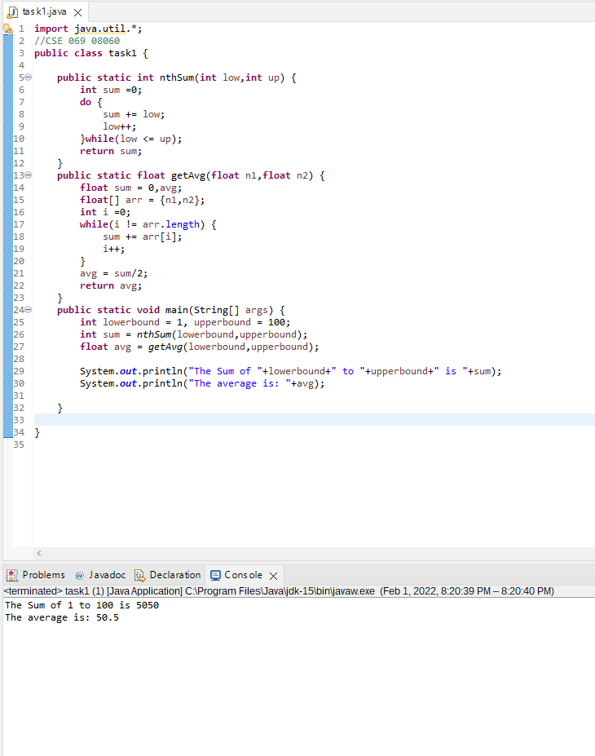
Task 2
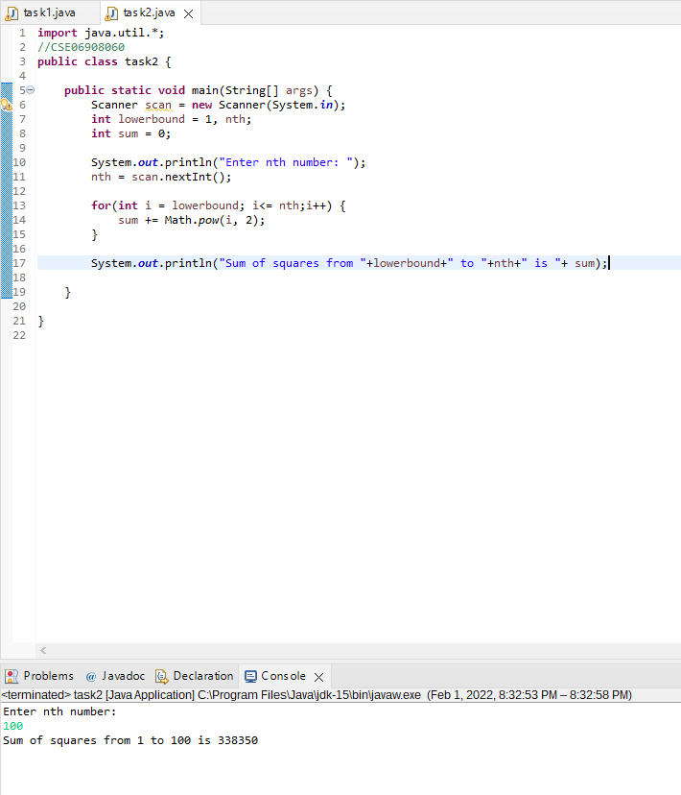

Task 3
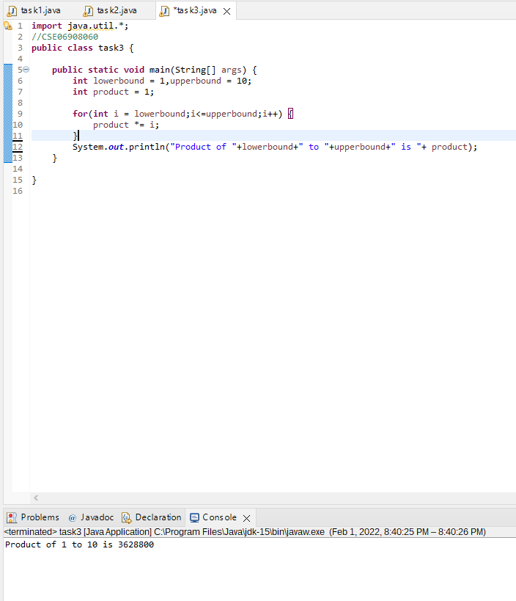

Task 4
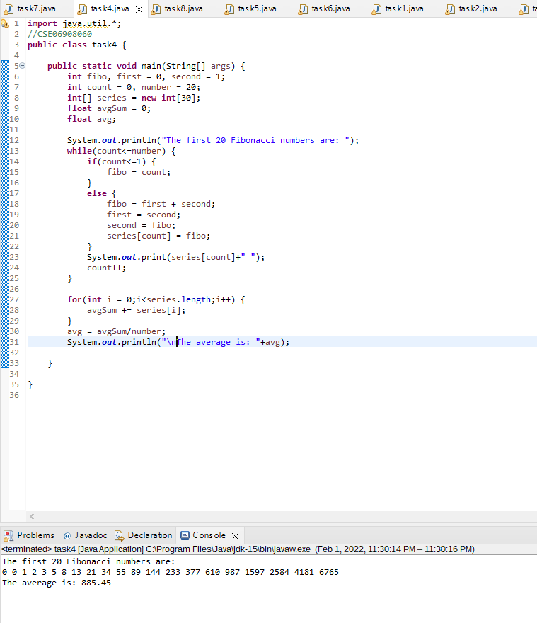

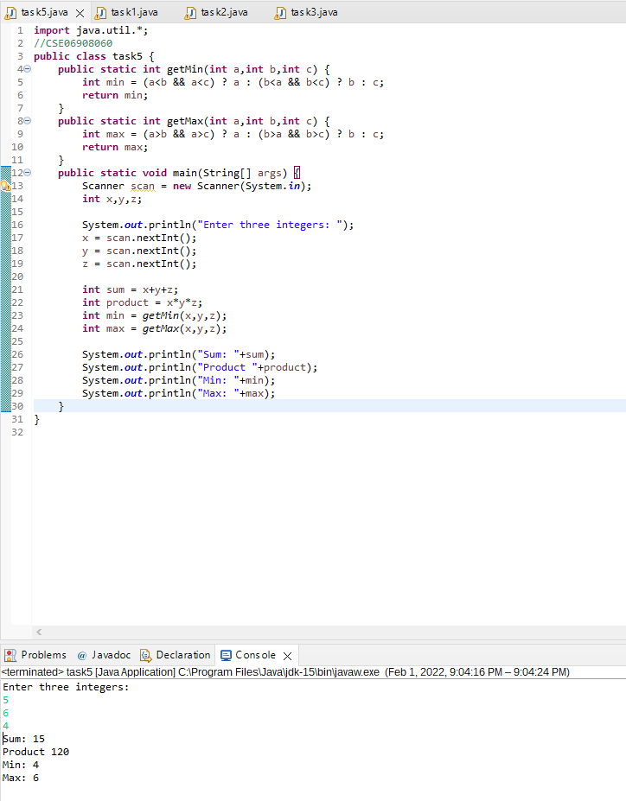
Task 5

Task 6
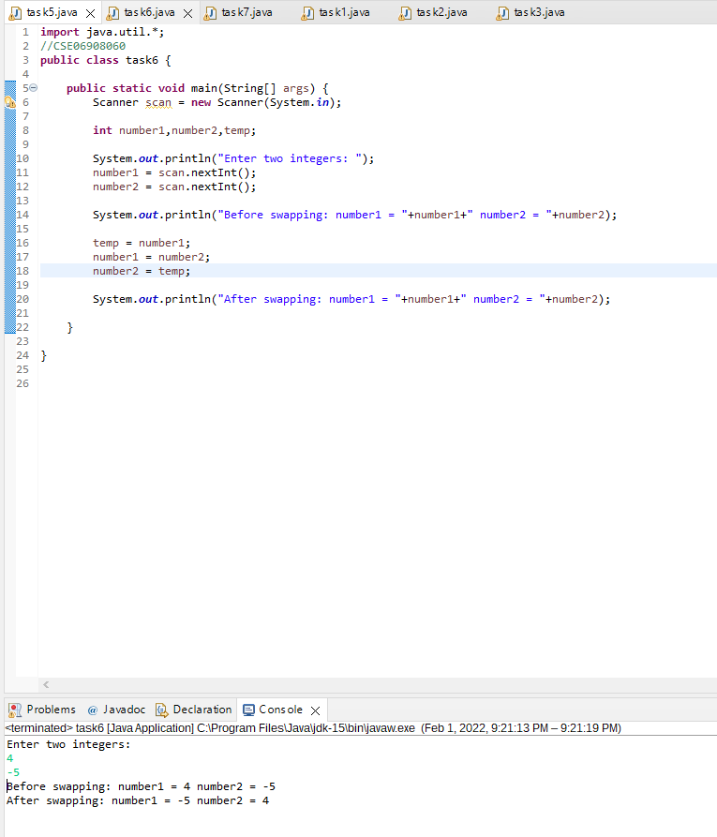

Task 7
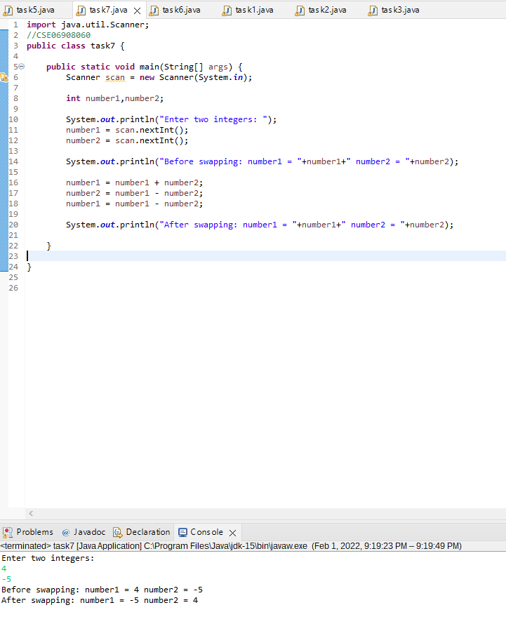
Task 8
